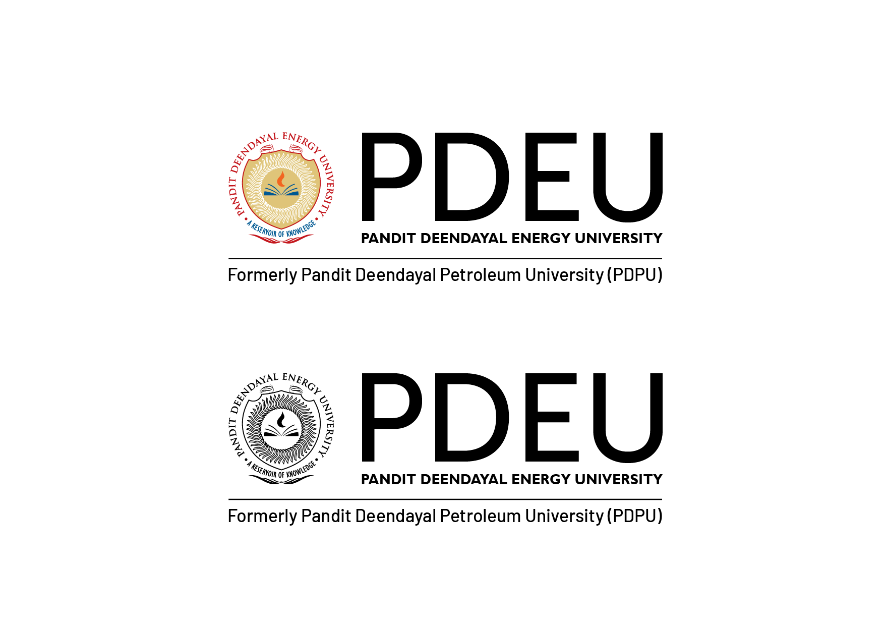**(Student Name)**

(School Name)

Pandit Deendayal Energy University

Gandhinagar, Gujarat

E-Mail Id:

Cell No:

Objective

In pursuit of challenging assignments that would facilitate the maximum utilization and application of my skills and expertise in making a positive difference to the organization.

Education Qualification

|  |  |  |  |  |
| --- | --- | --- | --- | --- |
| **Qualification** | **Institute** | **Board / University** | **Year Of Passing** | **CPI** |
| B.Tech (Branch) | (School Name) | Pandit Deendayal Energy University | 2010 | 7.00 |
| 12th / Diploma |  |  | 2006 | 75.00% |
| 10th |  |  | 2004 | 75.50% |

Industrial Orientation / Internship

Organization Name: Hindustan Petroleum Corporation Limited Duration: Apr 8 – Jun 7 2013

Brief of Visit / Internship:

Co-curricular Achievements and Trainings

* Android Certification
* Unity Certification
* Assistant trainer in bootcamp on Python at Royal Technosoft Pvt Ltd
* Conducted a complete coaching program on C programming language to the students from different states of India as well as from UK.

Extra Curricular Achievements

* Winner of Chess POCC
* IIM as Captain
* Captain in Energy Cup (upcoming)

Personal Information

|  |  |
| --- | --- |
| **Name** |  |
| **Languages Known** | **ENGLISH, HINDI, TAMIL** |
| **Permanent Address** |  |

Information provided above is true to the best of my knowledge.

**Place - Gandhinagar, Gujarat Name -**